**QSMART –POLARIZER REPLACEMENT**

**PROCEDURE**

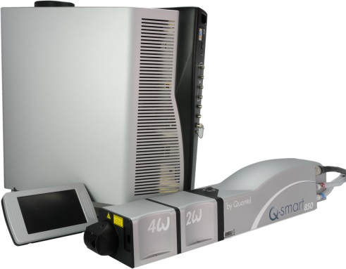

**Toolkit:**

Screwdrivers

Allen keys

Cover interlock holder RM100016AEnergy meter

Photodiode

**System**: QSMART

|  |  |  |  |
| --- | --- | --- | --- |
| |  |  | | --- | --- | | **SM010347** | **Q-SMART POLARIZER ASSY** | |  |

**Purpose**: This document details how to change and adjust the polarizer

|  |  |  |
| --- | --- | --- |
| Revision | date | modification |
| Initial issue | July 4, 2014 |  |
|  |  |  |
|  |  |  |
|  |  |  |

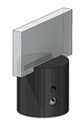

# DISASSEMBLING

* Turn the system off
* Disconnect cables and water hoses on the laser head side
* Remove the laser head cover.
* Remove the side plate (7 BHC 3x6)

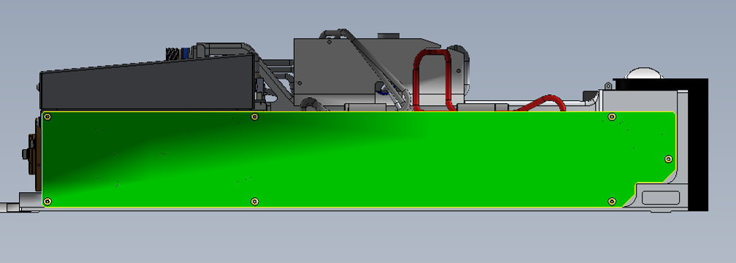

* Remove the polarizer (HC screw)

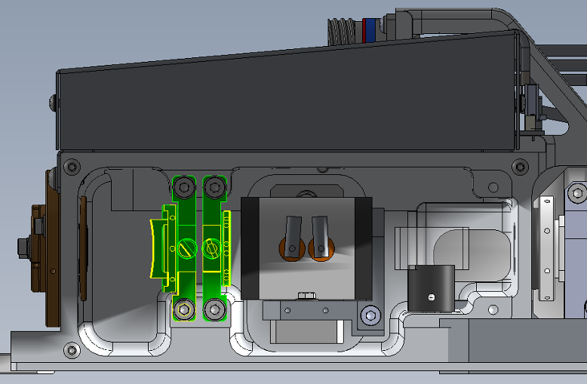

HC screw

# POLARIZER ALIGNEMENT

* 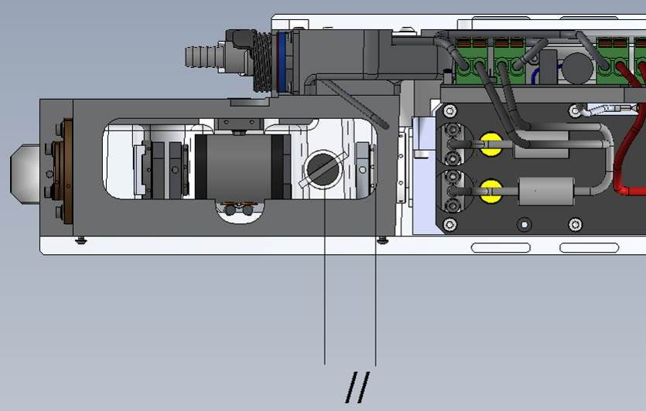Install the polarizer support on its axis.
* Orient it so the screw axis is parallel to the foundry (see picture) and the treated surface of the polarizer faces the pockels.
* Tight the screw.

# CLOSING THE LASER CAVITY

* Connect the photodiode, observe the fluorescence flashes and check that cavity remain closed while increasing the voltage up to 680V. If the Laser effect persists, repeat the alignment of the Pockels (see the Laser Adjustement procedure )

Tighten the maintaining of the Pockels and of the quarter wave plate and check that the closure of the cavity is maintained.

Replace the cover plate

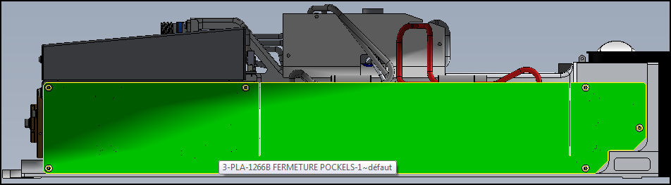

* Wait until the plate is the same temperature as the laser head to tighten.
* Tighten the back cavity mirror and check its alignment with the impact paper at 30cm. Re-adjust the back mirror if needed. (see the Laser Adjustement procedure)
* Turn the system off
* Disconnect cables and water hoses on the laser head side
* Replace the laser head cover

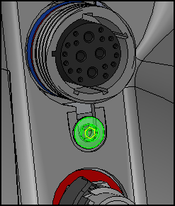

* Connect cables to the laser head
* Adjust lamp voltage to get 850mJ
* Check paper burns at 30cm, 1m et 2m to be confident

# SAVE PARAMETERS

* Save using Cmd = FPGMx2
* Save Excel File
* Close the Laser head and put warranty stickers   
  *Refer to "LH-Warranty Labels"*